

**3. Invitation Card / Brochure if available**



**5. Attendance Sheet:**

**Including Teachers, Students   
(Male & Female) Attendance**





**Prin.Dr.G.J.Fagare, Dr.S.N.Jagtap, Dr.V.R.Veer, Prof.V.B.Karade & All the other teachers with Students attended in farewell ceremony of B.Com-III.**

**Prin.Dr.G.J.Fagare, Dr.S.N.Jagtap, Dr.V.R.Veer, Prof.V.B.Karade & All the other teachers & Students attended in farewell ceremony.**

**Dr.G.J.Fagare gave presiding remarks & gave best wishes with his guidance to the students of B.Com-III for their Better Future.**

**Dr.S.N.Jagtap Head of the department gave introductory speech to and welcomed to the students by the department.**

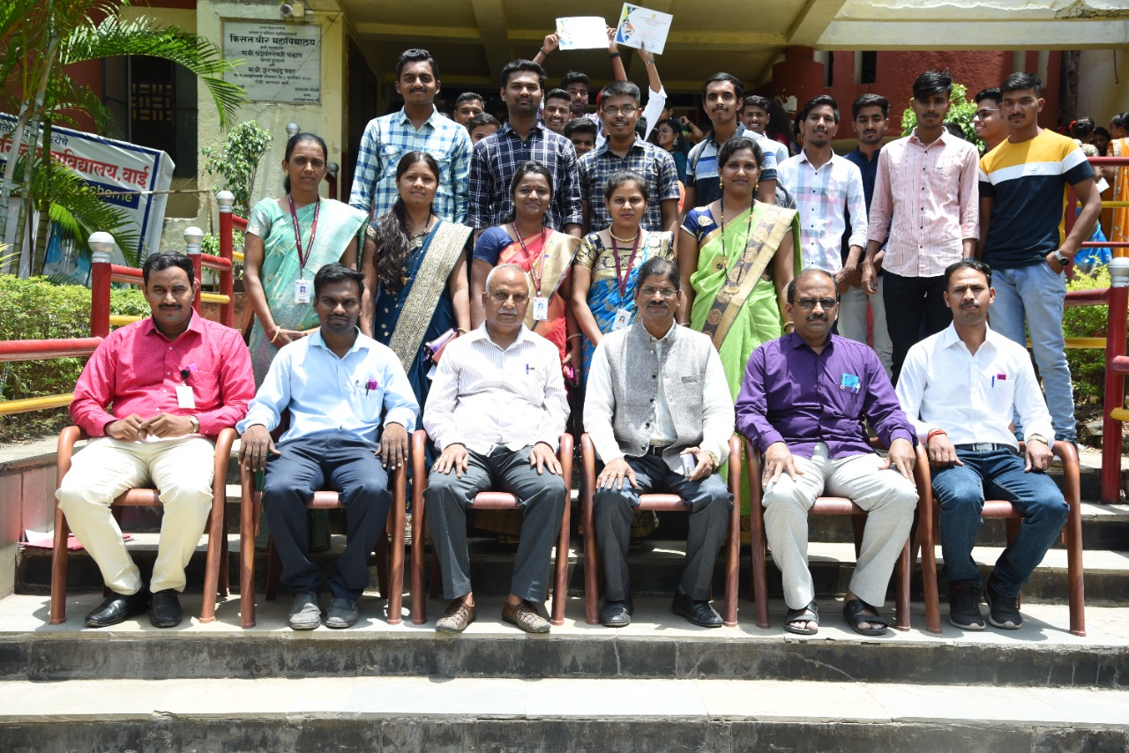**Paste the PDF**

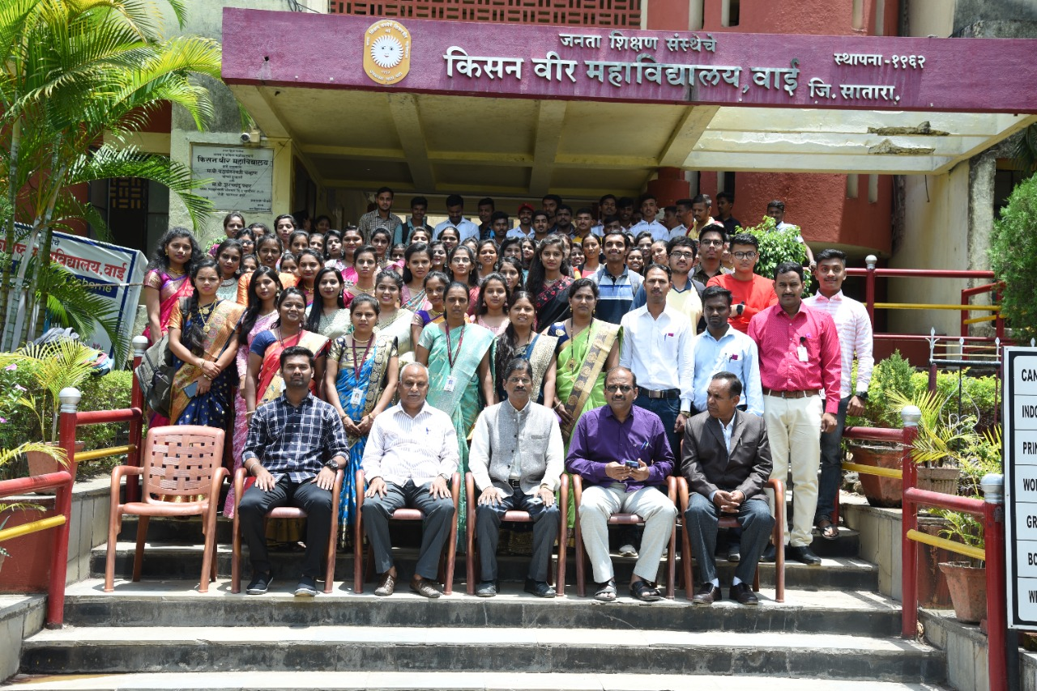 **PDF**

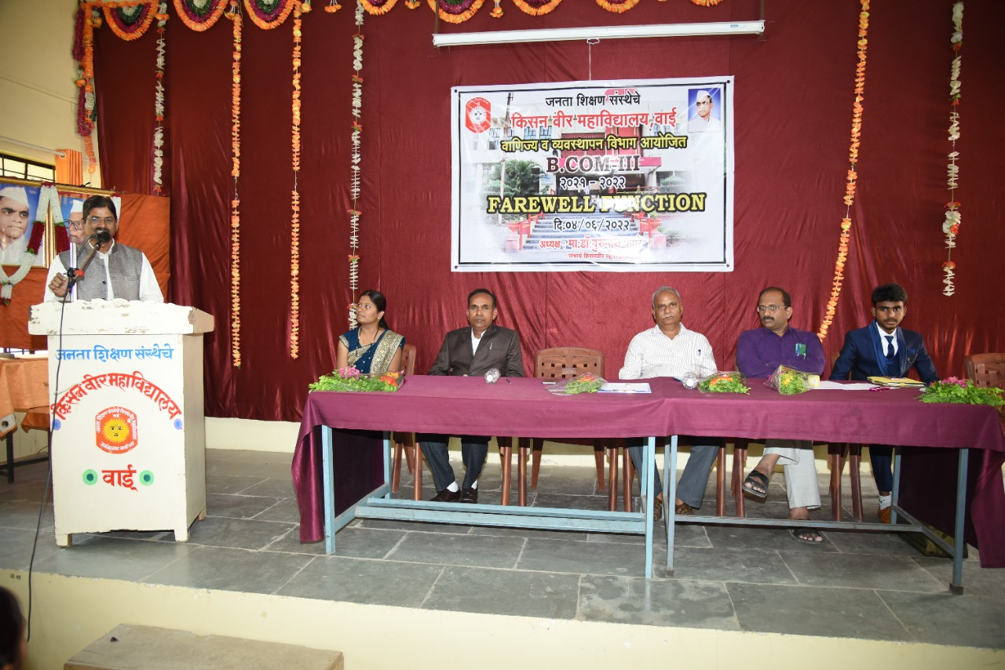**e the PDF**

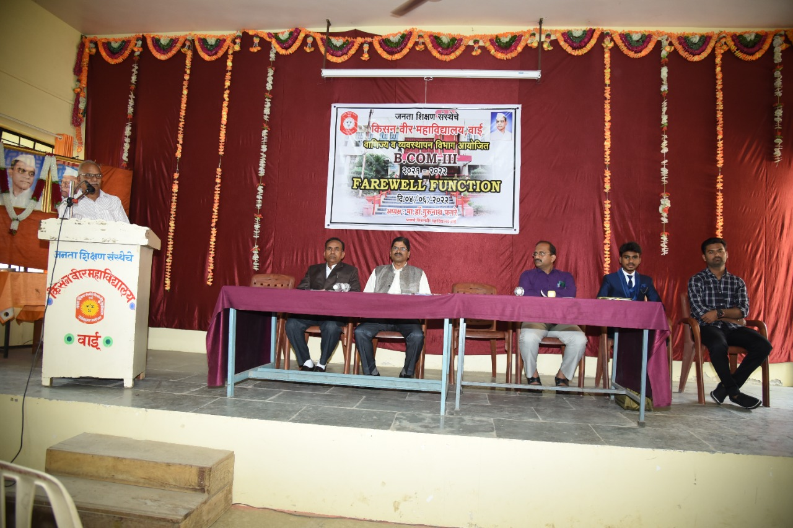**ste the PDF**

**5. Geo-tagged Photos With Caption**

**Combine all documents together and prepare one pdf document and upload it on respective activity menu of College Website.**